Operating Instructions

BT2200 Series Firmware Update Utility

Prerequisite Information
- Do not update more than one BT2200A platform at a time.
- The Firmware Update Utility is suitable for use under Windows XP, 7, 8, or 10 operating systems. For Windows XP, the utility requires Service Pack 3 or later.
- Download and install the BT2200A Firmware Update Utility onto your PC.
- Download the required revision of the firmware update file (BT2200_Update_XX.XX.dfu) onto your PC.

Firmware Update Procedure
- Interface your PC to the BT2200A platform by a LAN or USB connection. When using LAN use VXI-11. Do not use sockets.
- Start up the Firmware Update Utility. Enter the appropriate address into the connect box of the Utility, as shown in Figure 1.
- Click Browse on the Utility, then select the required revision of the firmware update file from its location on the C: drive. Click Open to enter the firmware update file’s path into the Utility’s file path box, as shown in Figure 2.
- On the “Updating System Components” box of the Utility the preferred choice is to use the default “That are out-of-date” so that only outdated components in the BT2200 platform get updated. However, when installing an earlier revision of a firmware update file, you must select the “All” radio button to do so.
- After the instrument address and firmware update file have been entered, click Update to start the firmware update process. The update will take several minutes to perform as each of the firmware components within the platform get updated. The BT2200 platform will automatically reboot as needed during the update process.
- When the firmware update is completed, you will get a “Firmware Update Succeeded!” in the Update Status box on the Utility, as shown in Figure 3. Upon completion, close the Utility. There no need to recalibrate the BT2200 platform after performing a firmware update.
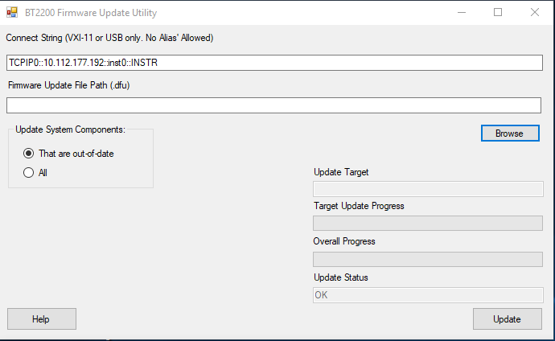
Figure 1. Firmware Update Utility interface

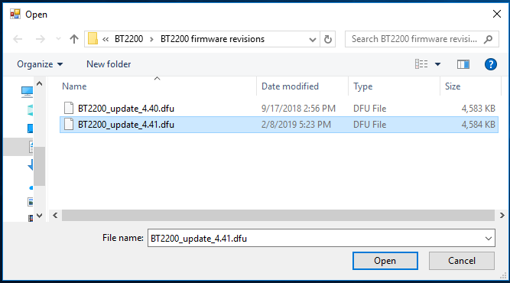
Figure 2: Selecting the firmware update file
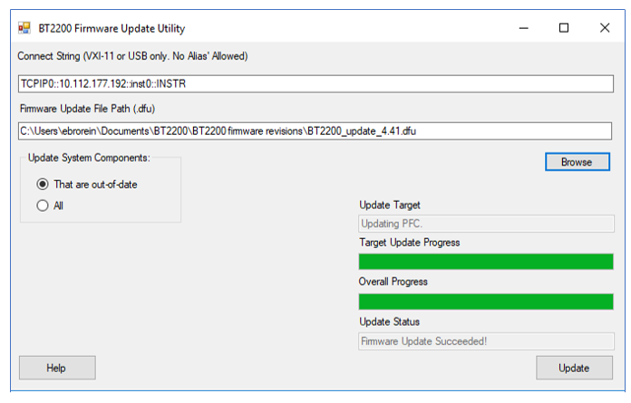
Figure 3: Successfully completed firmware update

This information is subject to change without notice
© Keysight Technologies 2019

